To update the REST API documentation

1. Clone the amcsrestapi.github.com repo

<https://github.com/amcsrestapi/amcsrestapi.github.io.git>

1. Open the index.html

Add a new select option for the version of the API that’s currently the latest

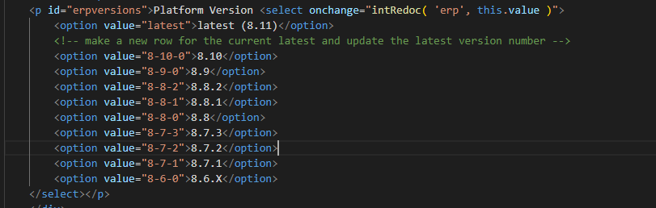

Change the version in the latest option to the version of platform you’re adding documentation for

1. Go to the erpswagger folder and update - xxxxlatest.json – so that it; named after the version of platform it’s for

E.g. erpswaggerlatest.json would become erpswagger8-12-1.json

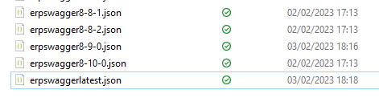

1. Do the same for endpointslatest.svg in the diagram folder
2. Go to an environment and save the swagger it generates to a file
3. Using this tool create a new latest swagger and erp, and copy these into the relevant folders in the amcsrestapi.github.com repo
4. Commit and Push the changes to the amcsrestapi.github.